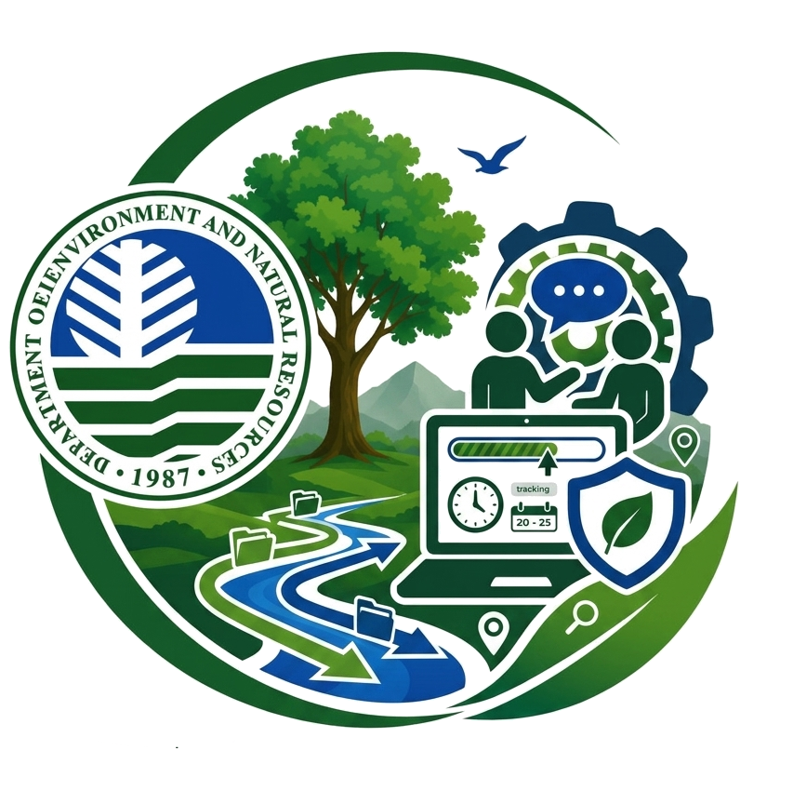
DENR REGION XII DTMIS
Users Manual
How to use the role-based Document Tracking and Monitoring Information System
Sample walkthrough role: CENRO Admin Record | Updated May 25, 2026

This manual explains the main screens, the purpose of key buttons, and the usual click path for day-to-day document work.

How To Use This Manual
The screenshots in this guide were captured from the live system on May 25, 2026. Your menu and available buttons may differ slightly depending on your assigned role, office, and permissions.
Important: Use your assigned account only. Tracking IDs, routing history, and attachments should be handled according to office policy.

Typical Daily Workflow
Step | What To Do
1 | Sign in with your assigned username and password.
2 | Review the dashboard to see new workload, alerts, and due items.
3 | Open Create / Intake when you need to encode a new document.
4 | Submit the intake, then open the tracking slip to confirm the record.
5 | Use the archive/search page when you need to find completed records.
6 | Open Profile Settings to maintain your email and password.

1. Sign In
Open the DTMIS sign-in page and enter your assigned username and password.
If you cannot sign in, use the password recovery link or contact your system administrator.
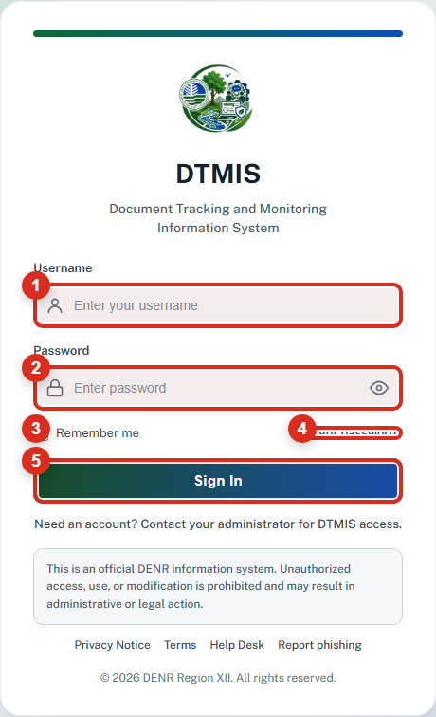
Figure 1. Sign-in screen

Walkthrough
Step | Action
1 | Open the system login page.
2 | Type your username and password.
3 | Click Sign In.

Button Guide
Callout | Purpose
1 | Username field. Type the username assigned to your account.
2 | Password field. Enter your current password.
3 | Remember me. Use this only on a secure work device.
4 | Forgot password. Opens the recovery process when you cannot sign in.
5 | Sign In button. Starts your session and sends you to your role dashboard.

2. Dashboard Overview
The dashboard is your starting point after sign-in.
It shows your role menu, current workload summary, and quick access to daily actions.
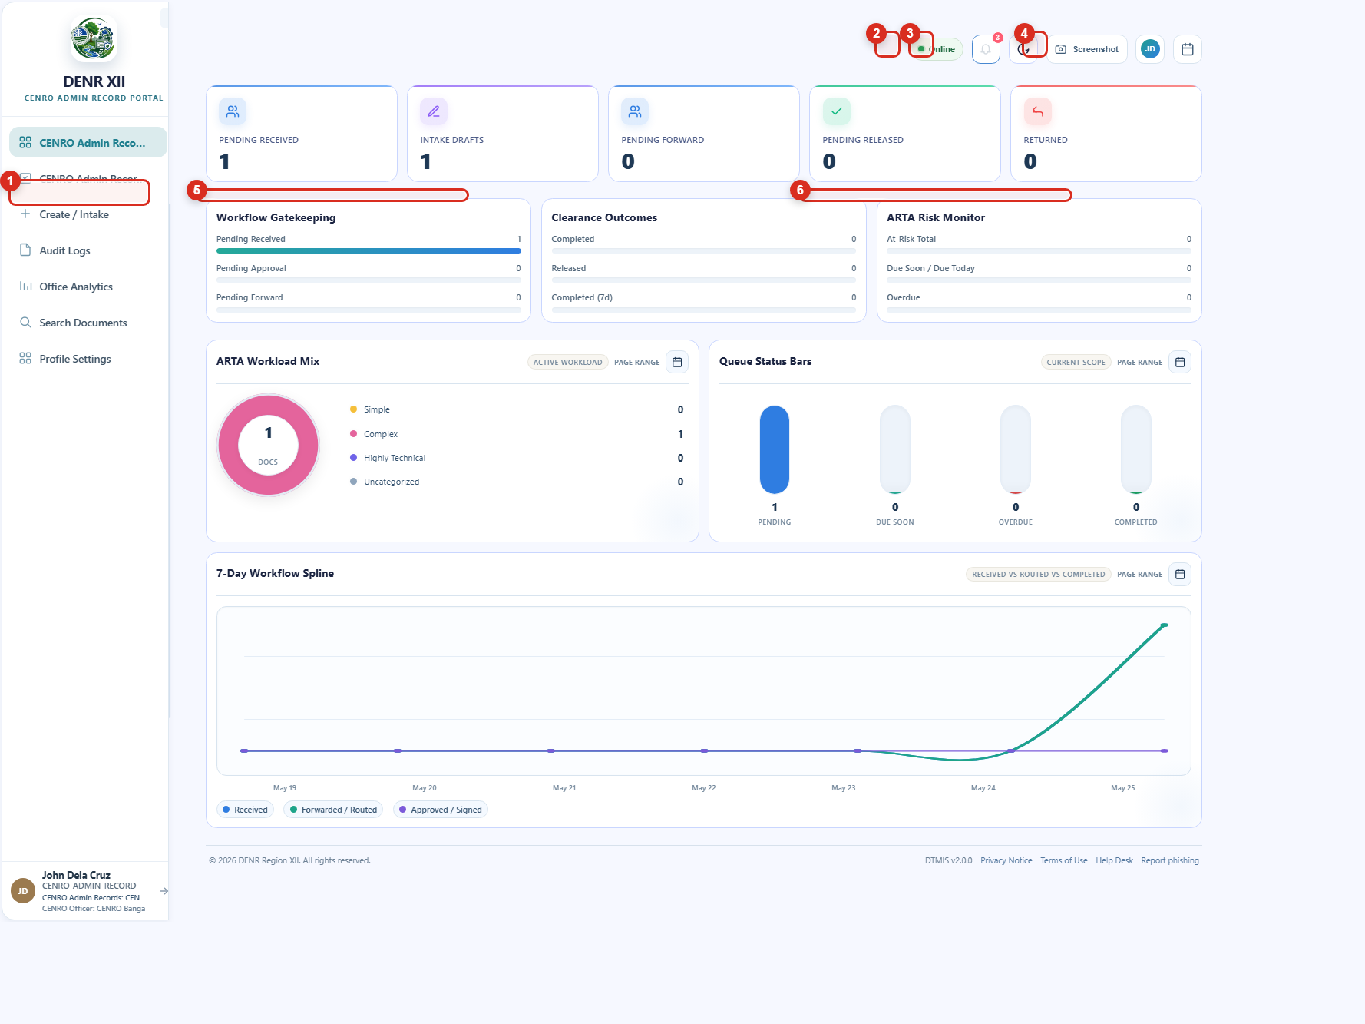
Figure 2. Dashboard overview

Button Guide
Callout | Purpose
1 | Create / Intake menu. Opens the page where new documents are encoded.
2 | Notifications bell. Shows routing updates and reminders.
3 | Theme switch. Changes the screen theme for comfort and visibility.
4 | Profile menu. Opens profile settings, screenshot tools, and logout.
5 | Workflow Gatekeeping panel. Summarizes documents waiting for action.
6 | ARTA Risk Monitor. Highlights due-soon or overdue workload.

3. Notifications Panel
Use notifications to monitor document movement without searching every record manually.
This is useful when you want a quick update on recently routed or received documents.
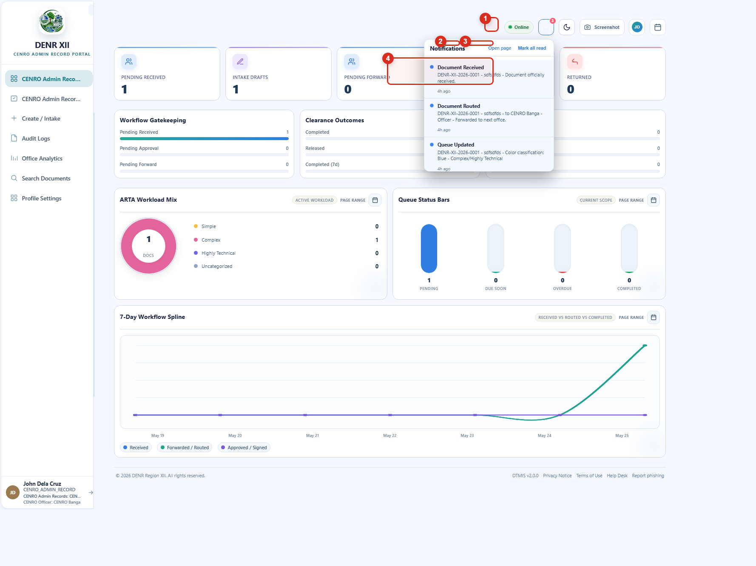
Figure 3. Notifications and alerts

Button Guide
Callout | Purpose
1 | Notifications bell. Click to open or close the alert panel.
2 | Open page. Moves to the full notifications page for longer review.
3 | Mark all read. Clears unread indicators after you review the items.
4 | Notification item. Opens the related document or tracking slip when available.

4. Create / Intake Workspace
Use the Create / Intake page to review recent intake records and open the intake form.
This page also provides quick document tools, filters, and tracking-slip access.
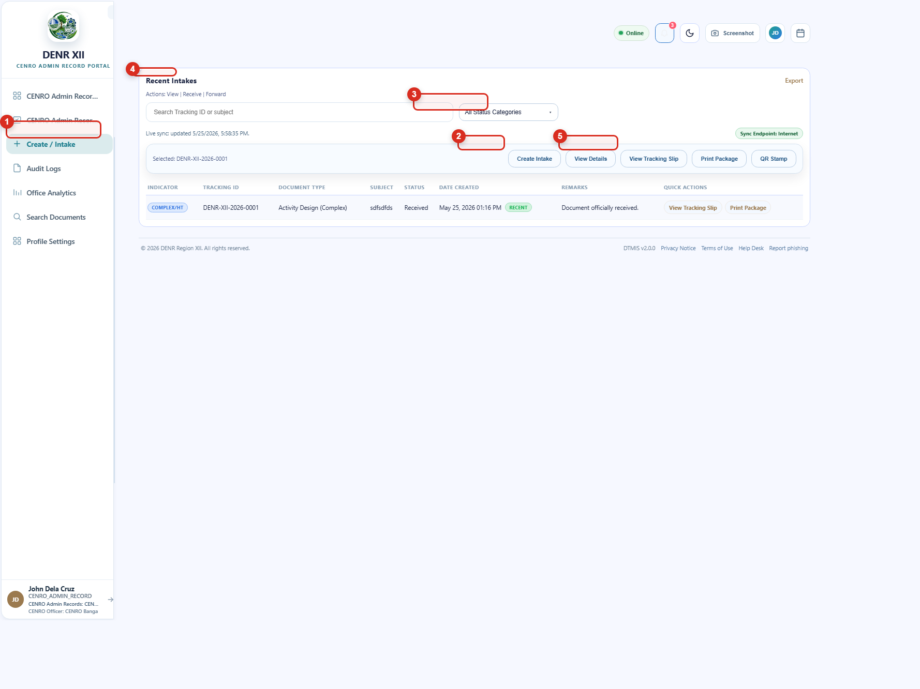
Figure 4. Create / Intake page

Walkthrough
Step | Action
1 | Click Create / Intake in the left menu.
2 | Click Create Intake.
3 | Fill in the form, then submit the document.
4 | Return to Recent Intakes and open the tracking slip to confirm the record.

Button Guide
Callout | Purpose
1 | Create / Intake menu. Confirms that you are in the encoding workspace.
2 | Create Intake button. Opens the document intake form.
3 | Status filter. Narrows the table to the queue status you want to review.
4 | Recent Intakes section. Lists the latest encoded documents.
5 | View Tracking Slip. Opens the slip for the selected record.

5. Create Document Intake Form
The intake form is where you encode a new document before it is tracked inside the system.
Complete the required fields carefully so the receiving office sees the correct details.
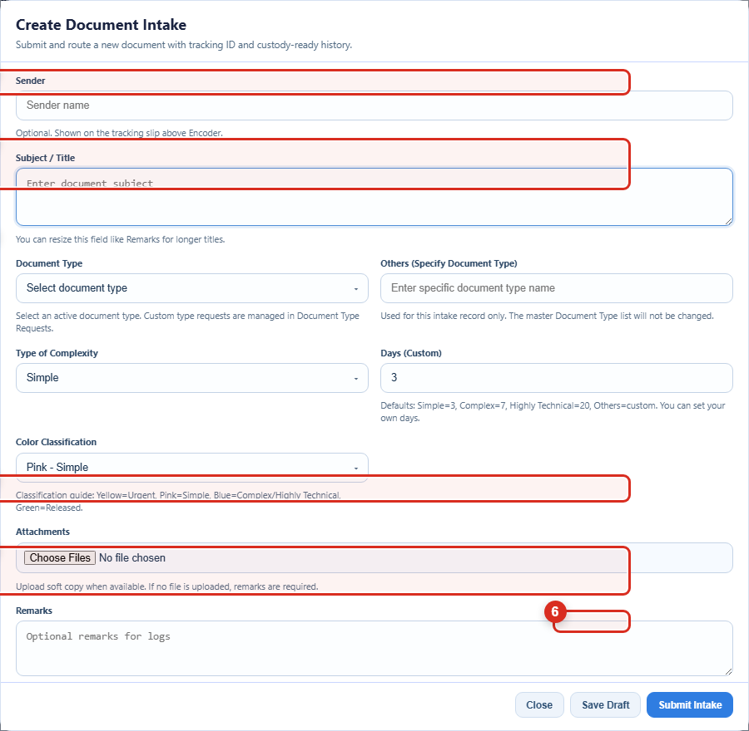
Figure 5. Create Document Intake form

Button Guide
Callout | Purpose
1 | Sender. Enter the external sender name when applicable.
2 | Subject / Title. Type the main document title or subject.
3 | Document Type. Choose the correct document classification.
4 | Attachments. Upload the digital copy when available.
5 | Remarks. Add extra notes for the log or receiving office.
6 | Submit Intake. Saves the intake and generates the tracking-ready record.

6. Tracking Slip
The tracking slip is the main proof of document movement inside DTMIS.
Use it to review the tracking ID, origin, subject, and the custody timeline.
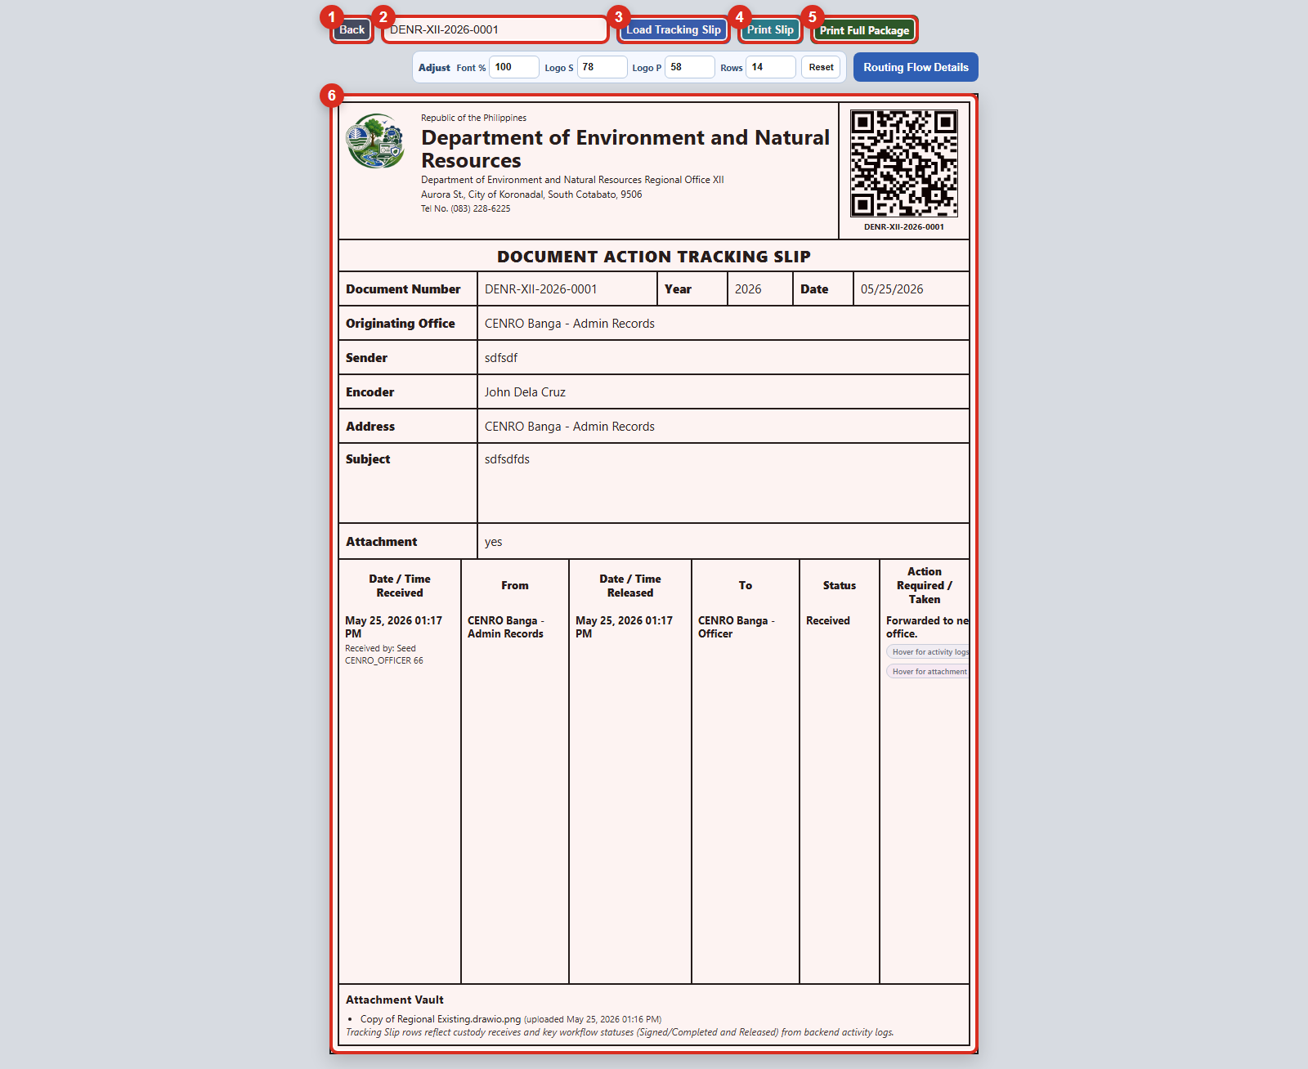
Figure 6. Tracking slip view

Walkthrough
Step | Action
1 | Open a record from Recent Intakes or another queue page.
2 | Review the tracking ID, subject, and offices shown in the slip.
3 | Use Print Slip or Print Full Package when a hard copy is needed.

Button Guide
Callout | Purpose
1 | Back button. Returns you to the previous page.
2 | Tracking ID field. Enter another tracking number when you want to load a different record.
3 | Load Tracking Slip. Opens the slip for the tracking ID in the field.
4 | Print Slip. Prints the current tracking slip.
5 | Print Full Package. Opens the larger print package with more record details.
6 | Tracking slip body. Shows the official slip information and routing timeline.

7. Search Completed Records
Use the search/archive page to find completed records under your office scope.
This is helpful for historical review, retrieval, and audit preparation.
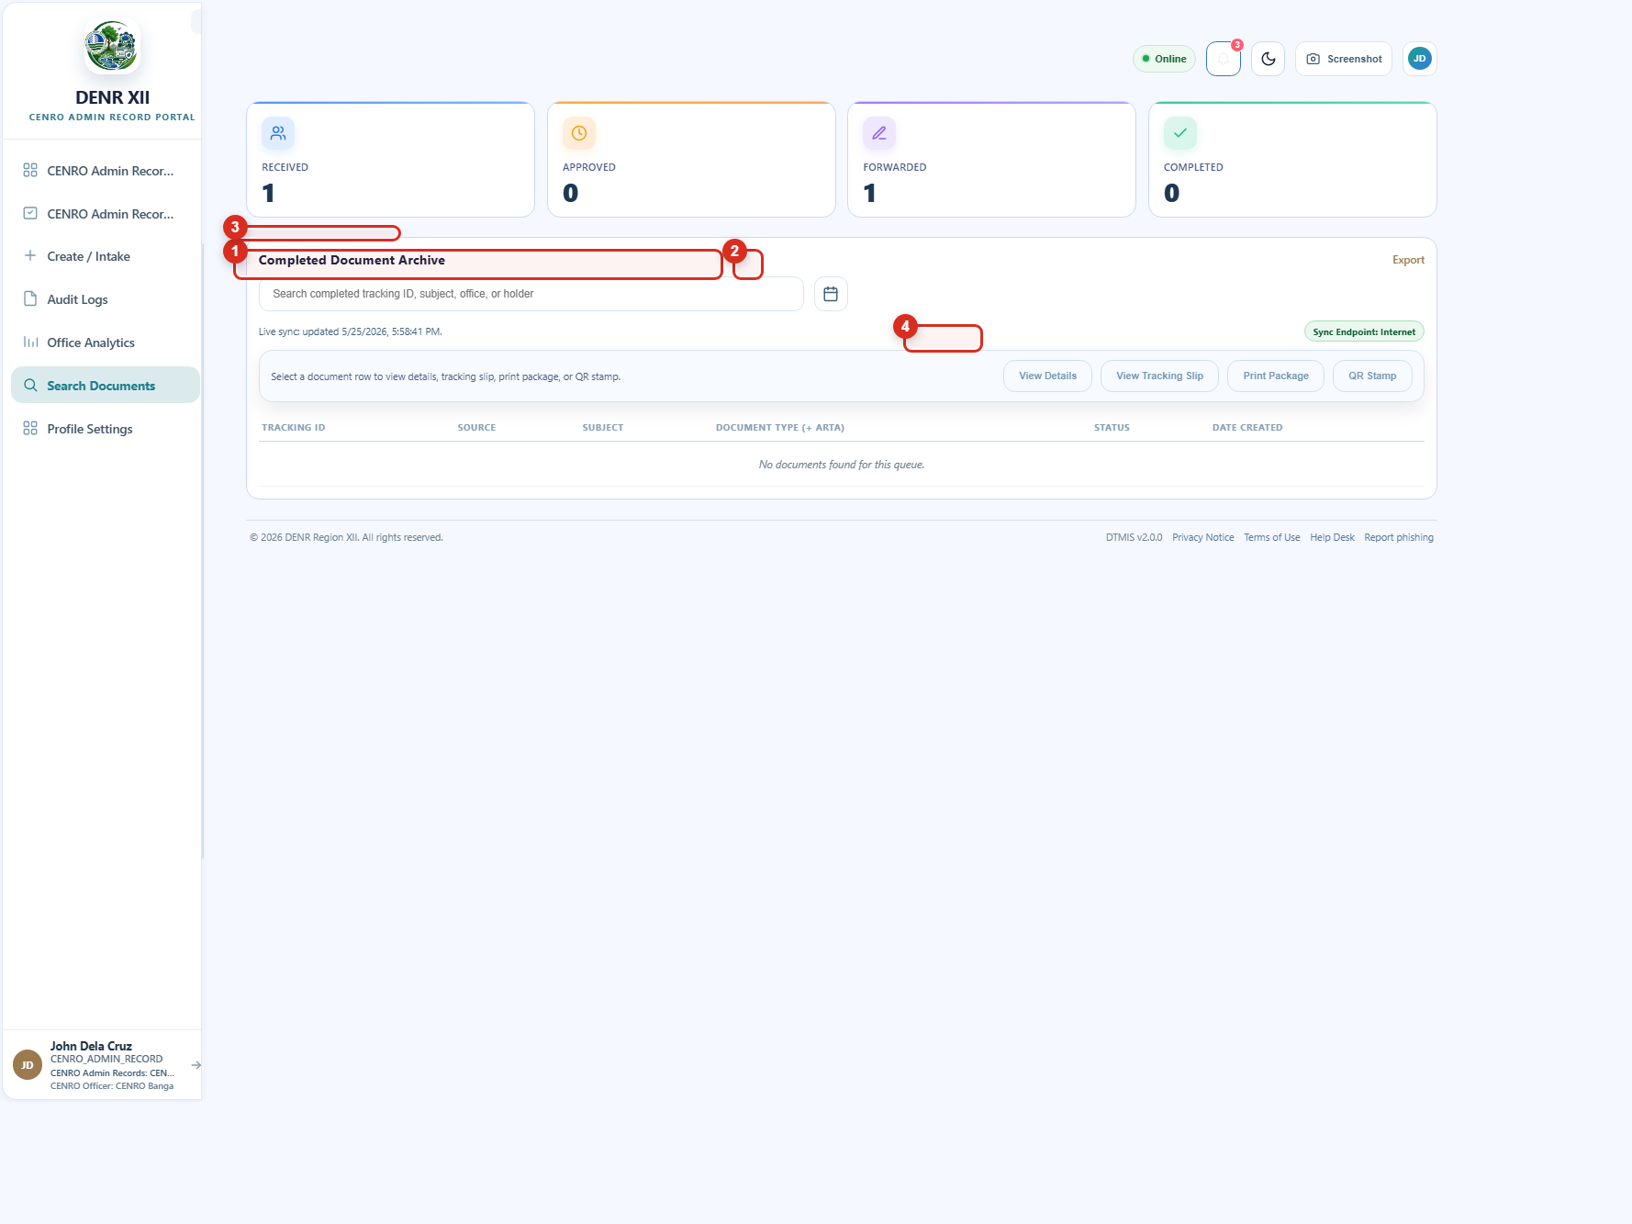
Figure 7. Search completed records

Button Guide
Callout | Purpose
1 | Archive area. Main workspace for reviewing completed documents.
2 | Date filter. Narrows the archive to a selected date range.
3 | Completed Document Archive. The results table for completed records.
4 | View Details. Opens the selected document details panel.

8. Profile Settings
Use profile settings to confirm your account details and maintain your access.
You can update your email address and change your password from this page.
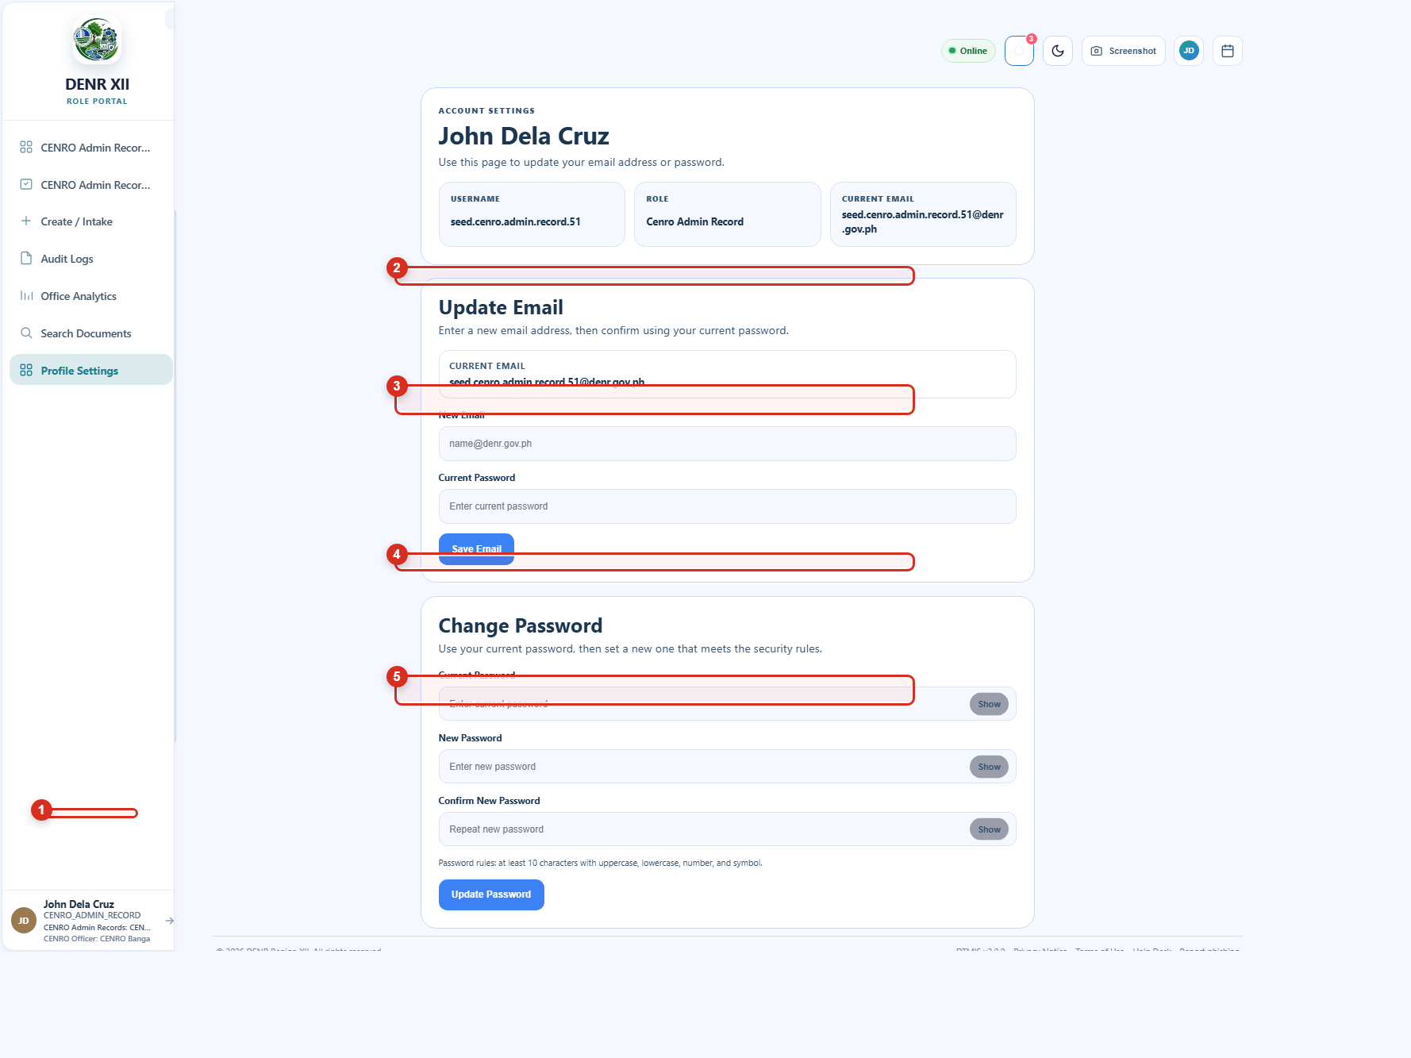
Figure 8. Profile settings page

Walkthrough
Step | Action
1 | Open Profile Settings from the sidebar or profile menu.
2 | Update your email or password, depending on your need.
3 | Enter your current password when the page asks for verification.

Button Guide
Callout | Purpose
1 | Account summary. Shows your name, username, and current role.
2 | Update Email section. Starts the email update process.
3 | Email field. Enter the replacement Gmail or DENR email address.
4 | Change Password section. Opens the password update form.
5 | New password field. Type the password you want to use next.

Support Tips
When reporting a system issue, include the page name, the tracking ID if available, and a screenshot of the problem.
If You Need To... | Best Action
Reset access | Use the password recovery page or contact your system administrator.
Trace a document | Open the tracking slip and confirm the latest office and action.
Find a completed record | Use the archive/search page with the date filter.
Change account details | Open Profile Settings and verify changes with your current password.
End of manual. Use this guide together with your office procedures and the system's Support Center links.

